=====================================================================================

A sincere **Thank You** to all of our corporate sponsors.

Your continued support of our annual conference is greatly appreciated!

=====================================================================================

**Bronze Sponsors**

20/20 Geomatics

Altus Group

Chamney Crushing

CIBC

Cogent Business Consulting

Cornerstone Credit Union

Custom Truck Sales Inc.

Holm Raiche Oberg, CPAs P.C. Ltd.

Mobile Paving

Munisoft

Percy H. Davis Ltd.

Prairie Dog Rural Services Ltd.

Prairie Mapping Services

Procyk Bros. Transport Ltd.

Robb & Dowling

Saskatchewan Blue Cross

Saskatoon Inn & Conference Centre

Schulte Industries

Shaw Earth Moving Inc.

Synergy Credit Union—Maidstone

Triod Supply (2011) Ltd.

Western Litho Printers

**Silver Sponsors**

Capital “I” Industries

Collins Barrow PC, LLP

Fast Trucking Service Ltd.

Markusson New Holland of Regina

Meridian Surveys Ltd.

Plains Midstream Canada

Prairie Centre Credit Union

RBC - Royal Bank

Redhead Equipment

Robertson Stromberg LLP

SaskTel

SMS Equipment Inc.

Tire Stewardship of Saskatchewan

TransCanada Keystone Pipeline, Limited Partnership

**Gold Sponsors**

*Elk Ridge Resort*

*Gord Krismer & Associates Ltd.*

*Janke Jellicoe LLP*

*Prairie Steel Products Ltd.*

*Professional Building Inspections, Inc.*

*wood. PLC*

**Platinum Sponsors**

*ATS Traffic Sask Ltd.*

*Brandt Tractor Ltd.*

*Canada Culvert*

*Crescent Point Resources Ltd. Partnership*

*Delta Regina Marriott*

*Enbridge*

*Finning Canada*

*Maxium Chemical International*

*Milltek Surveys Ltd.*

*Ministry of Government Relations*

*Resource Management International Inc.*

*SaskPower*

*W. F. Botkin Construction Ltd.*

*WSP Canada Inc.*

**Diamond Sponsor**

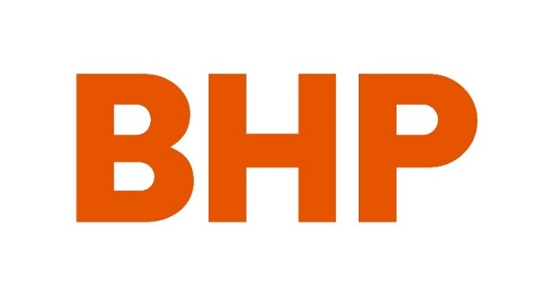

SMHI_colour_EMBOSS3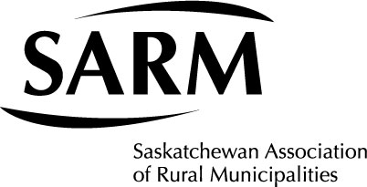

**Triple Diamond Sponsor**